First To 50!
Year 2: aim of this game is to be the first to reach 50 using addition. This game can be played in 2s or small groups.
How to Play:
Resources: pack of playing cards, whiteboard or paper for jottings.
Rules: Ace = 1, Picture cards = 11
- Deck of cards in the middle face down, each player to have a whiteboard/paper to do jottings.
- First player to take a card, turn over and place in middle.
- Next player to take a card, turn over and place in middle.
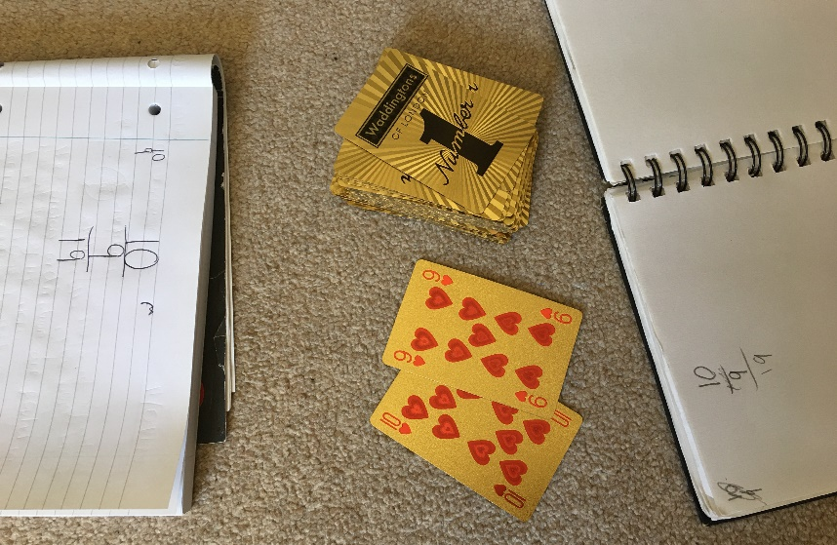
- All players to add the numerical value of cards and jot down – players can use written method if needed but aim is to add as quickly as possible. Check everybody agrees total – if not, all players must check calculations to come to same total.

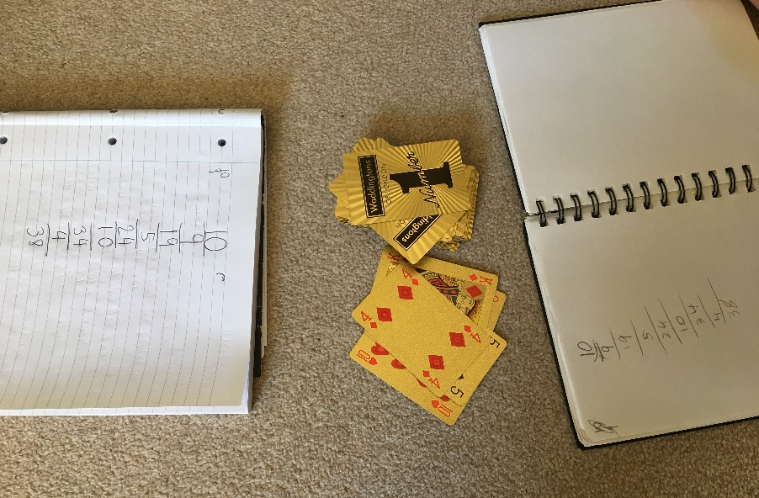
- Continue taking turns, adding and recording the total.

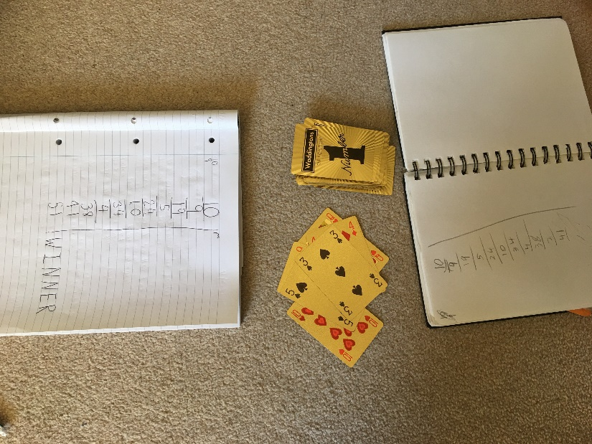
- Continue this until the total reaches 50. The quickest person to add to 50 is the winner!

Variation ideas:
- The total number can be changed to alternative target, eg 100 when children are getting quicker/secure.
- Subtraction can be applied instead of addition, children can begin at 50 (or different number) and aim to get to 0 (by subtracting value of cards) as quick as possible.
- Values of cards can be changed – Ace = 11, Jack = 12, Queen = 13, King = 14
- Two cards can be placed down at each turn (instead of one) to increase difficulty.
- Time the class playing, for example, the child with the biggest total in 2 mins is the winner.
- Use concrete objects/tens frames/place value grids/number lines to help calculate
- Use Ace-9 cards – turn over two cards to create a two-digit number to achieve bigger target, eg 500.

